PR Helper example -
Step 1 –
Select the directory.

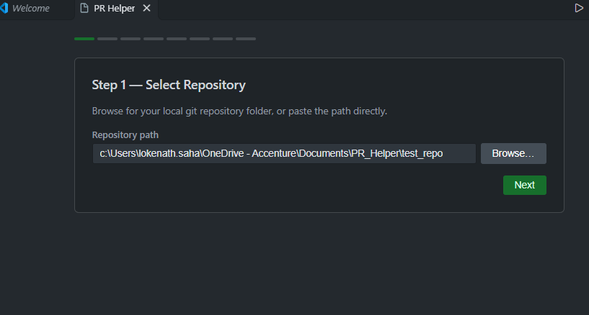
Step 2 –
It will auto detect branches if it is a cloned repo.

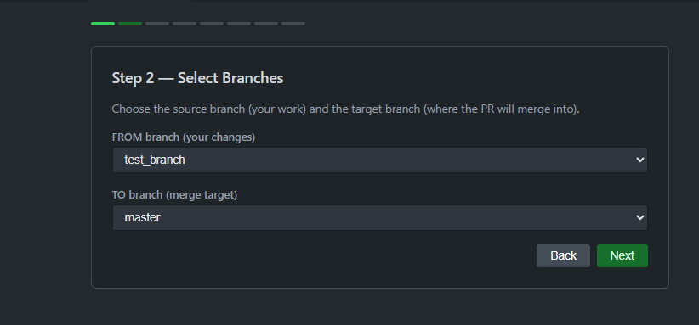
Step 3 –
Select the commits you want to analyze. 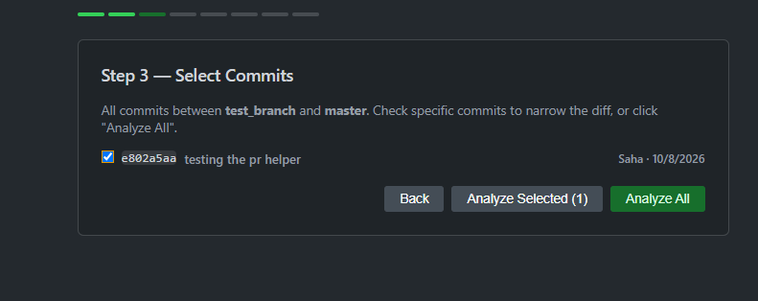
Step 4.A –
Select AI provider, GitHub Copilot does not require any API key and you must login to you GitHub copilot account.
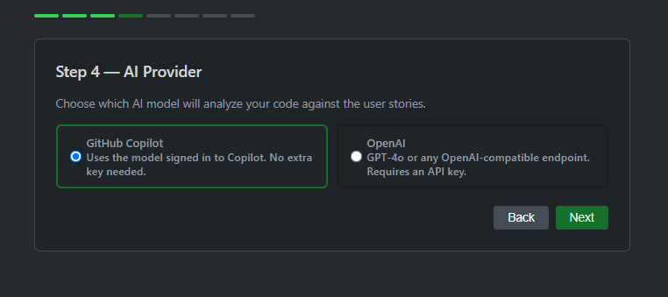

Step 4.B-
Or you can select OpenAI / Azure OpenAI and put endpoint, deployment name and API key use some other model hosted by you. It will be saved for future use, and you can add more configurations if required.
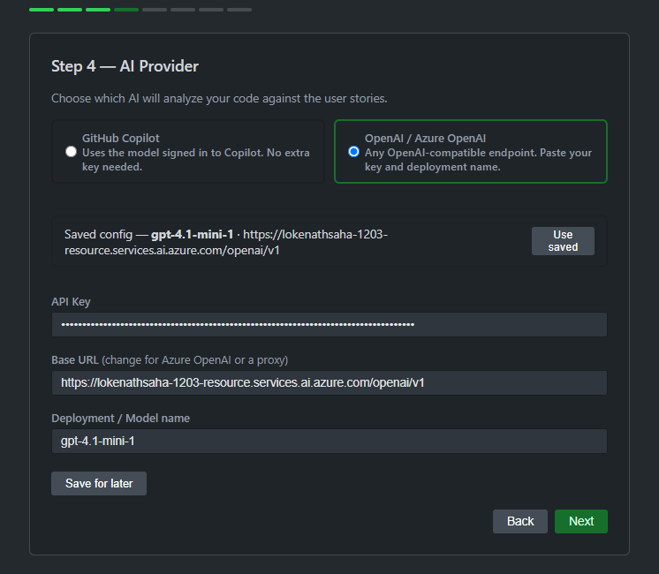

Step 5 –
If the repo is cloned from azure DevOps Repo then Org URL will auto filled, otherwise you have to specify that and put the PAT from ADO, this will be saved for ease of use later, you can change this later if required.
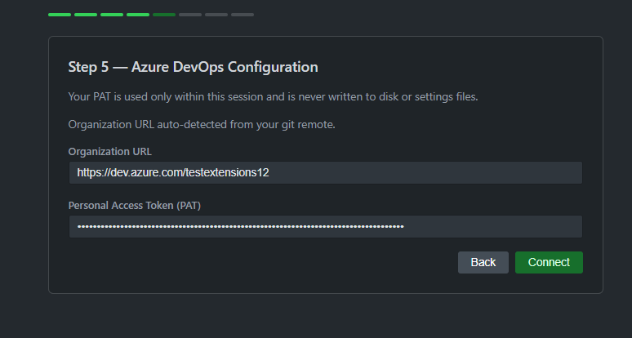

Step 6 –
Project and repo will be auto loaded you need to select the sprint and user stories you want to analyze against.
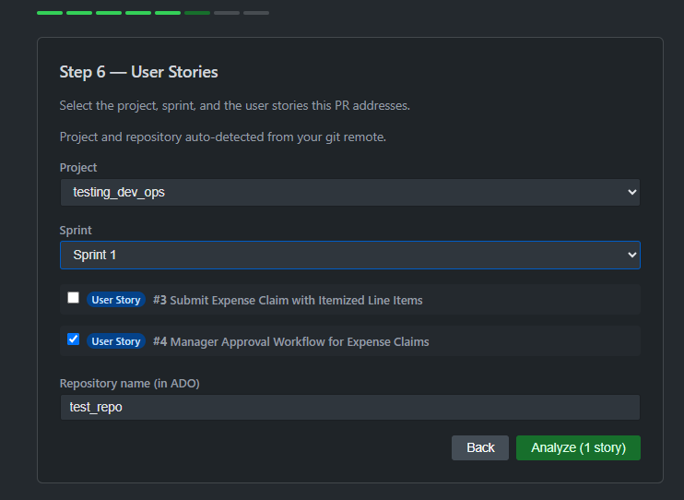

Step 7 –
Analysis report will show FAIL if it failed to complete the criteria’s, or PASS depending on the commit.
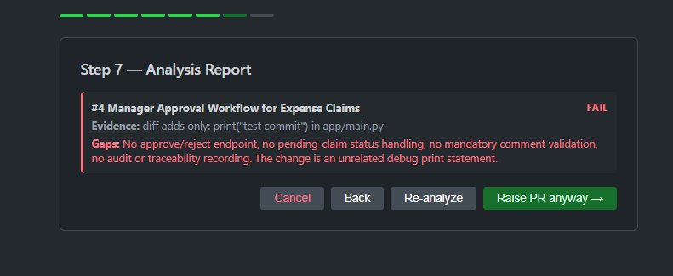
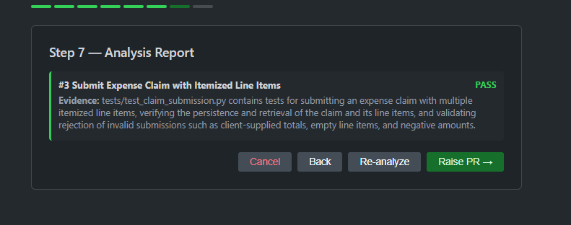

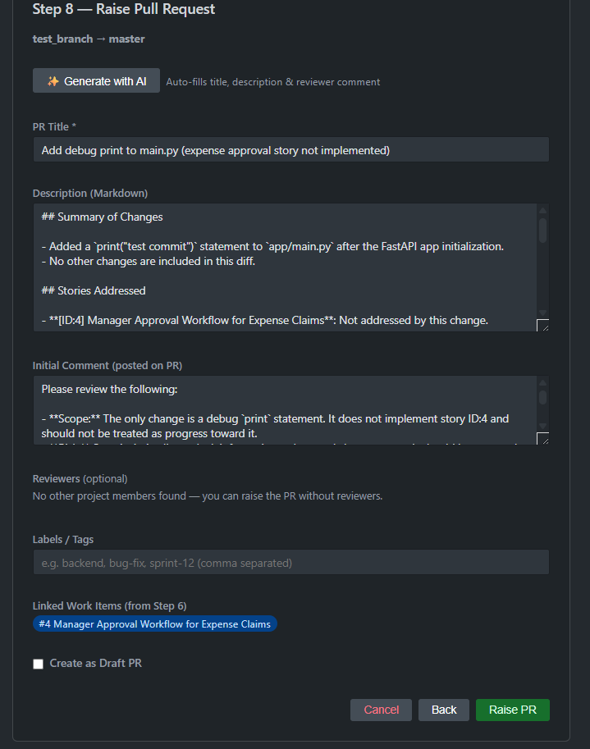
Step 8 -
Then you can Raise PR from here, click Generate with AI to Generate PR title, description and Initial Comments.

Step 9 -
It will create the PR and share the link with you.

